Weekly Meal Planner & Grocery Generator

Abstract :
The Weekly Meal Planner & Grocery Generator is a digital solution that simplifies meal preparation and grocery shopping. It integrates nutritional planning, recipe selection, and automated grocery list generation into a single system. By allowing users to customise dietary preferences, portion sizes, and budget constraints, the planner ensures balanced meals throughout the week while reducing food waste and saving time. The grocery generator automatically compiles ingredients from selected recipes into a structured shopping list, categorised for convenience. This tool promotes healthier eating habits, streamlines household management, and enhances efficiency in both cooking and shopping. Its adaptability makes it suitable for individuals, families, and organisations seeking organised and cost-effective meal planning.

Advantages :
- Health & Nutrition
  - Ensures balanced meals with proper nutrients.
  - Helps manage dietary restrictions (diabetic, gluten-free, keto, etc.).
  - Encourages portion control and healthier eating habits.
- Time Efficiency
  - Saves time by eliminating daily “what to cook” decisions.
  - Streamlines grocery shopping with ready-made lists.
  - Reduces time spent on meal preparation through organised planning.
- Cost Savings
  - Prevents unnecessary purchases by listing only required items.
  - Suggests budget-friendly ingredient substitutions.
  - Minimises food waste by reusing leftovers in planned recipes.
- Convenience & Organisation
  - Categorised grocery lists (produce, dairy, grains, etc.) make shopping faster.
  - Easy customisation for individuals, families, or groups.
  - Can sync with apps or devices for reminders and inventory tracking.
- Sustainability
  - Reduces food waste by optimising ingredient usage.
  - Encourages seasonal and local produce consumption.
  - Promotes eco-friendly shopping habits.
- Adaptability
  - Suitable for different lifestyles: students, professionals, families.
  - Can adjust for cultural cuisines and regional food availability.
  - Flexible enough to handle multiple dietary preferences in one household.

Implementation :
import java.util.Scanner;

public class WeeklyMealPlanner {

// Method to display weekly plan
static void displayPlan(String[] days, String[] meals) {
System.out.println("\n📅 Weekly Meal Plan:");
for (int i = 0; i < days.length; i++) {
System.out.println(days[i] + ": " + meals[i]);
}
}

// Recursive method to count total meals planned
static int countMeals(int n) {
if (n == 0) return 0; // base case
return 1 + countMeals(n - 1); // recursive case
}

public static void main(String[] args) {
Scanner sc = new Scanner(System.in);

String[] days = {"Monday", "Tuesday", "Wednesday", "Thursday", "Friday", "Saturday", "Sunday"};
String[] meals = new String[7];

// Input meals using Scanner
System. outprintln("Enter your meal plan for the week:");
for (int i = 0; i < days.length; i++) {
System.out.print(days[i] + ": ");
meals[i] = sc.nextLine();
}
System.out.println("\nDo you want to view your plan or grocery list?");
System.out.println("1. Weekly Plan\n2. Grocery List");
int choice = sc.nextInt();
sc.nextLine(); // consume newline

switch (choice) {
case 1:
displayPlan(days, meals);
break;
case 2:
System.out.println("\n🛒 Grocery List (ingredients separated by commas):");
for (String meal: meals) {
// simple loop to split ingredients
String[] items = meal.split(",");
for (String item: items) {
System.out.println("- " + item.trim());
}
}
break;
default:
System. outprintln("Invalid choice!");
}
int totalMeals = countMeals(meals.length);
System.out.println("\nTotal meals planned: " + totalMeals);

sc.close();
}
}

Output :
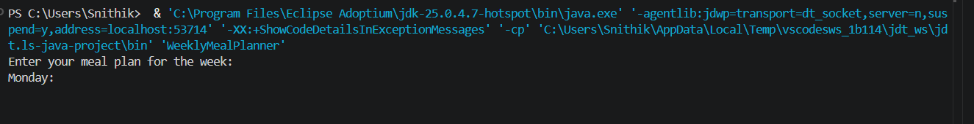
Conclusion:
The Weekly Meal Planner & Grocery Generator simplifies meal planning and shopping by combining Java programming concepts like arrays, control flow, methods, and recursion. It helps users organise meals, generate grocery lists, save time, reduce waste, and promote healthier eating. This project shows how computational thinking and structured programming can solve real-life problems efficiently.

